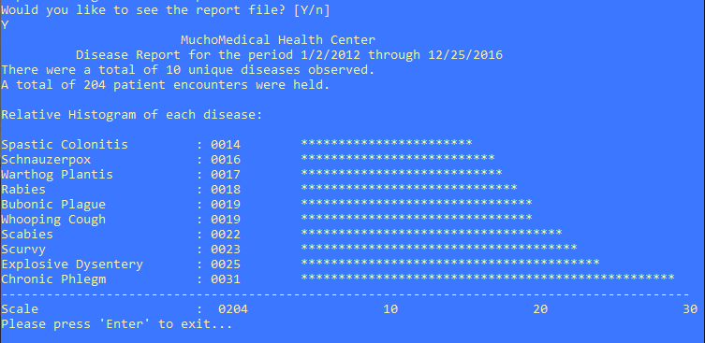

^Initial window

^Report file is generated

^File contents shown